**Project Design Phase-II**

**Technology Stack (Architecture & Stack)**

|  |  |
| --- | --- |
| Date | 18 October 2022 |
| Team ID | PNT2022TMID40359 |
| Project Name | A novel method for handwritten digit recognition systems |
| Maximum Marks | 4 Marks |

**Technical Architecture:**

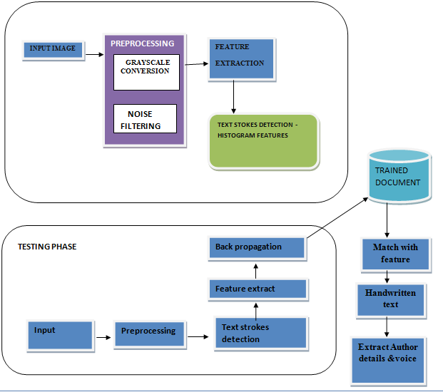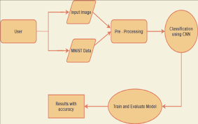

**Table-1 : Components & Technologies:**

|  |  |  |  |
| --- | --- | --- | --- |
| **S.No** | **Component** | **Description** | **Technology** |
|  | User Interface | How user interacts with application e.g.  Web UI, Mobile App, Chatbot etc. | HTML, CSS, JavaScript |
|  | Application Logic-1 | Logic for a process in the application | Java / Python |
|  | Application Logic-2 | Logic for a process in the application | IBM Watson STT service |
|  | Application Logic-3 | Logic for a process in the application | IBM Watson Assistant |
|  | Database | Data Type, Configurations etc. | MySQL, NoSQL |
|  | Cloud Database | Database Service on Cloud | IBM DB2, IBM Cloudant |
|  | File Storage | File storage requirements | IBM Block Storage or Other Storage Service or Local Filesystem |
|  | External API-1 | Purpose of External API used in the application | IBM Weather API |
|  | External API-2 | Purpose of External API used in the application | Aadhar API |
|  | Machine Learning Model | Purpose of Machine Learning Model | Object Recognition Model |
|  | Infrastructure (Server / Cloud) | Application Deployment on Local System / Cloud  Local Server Configuration:  Cloud Server Configuration : | Local, Cloud Foundry. |

**Table-2: Application Characteristics:**

| **S.No** | **Characteristics** | **Description** | **Technology** |
| --- | --- | --- | --- |
|  | Open-Source Frameworks | The open-source framework used are listed. | Technology of Opensource framework |
|  | Security Implementations | Listing all the security/access controls implemented, use of firewalls etc. | e.g. SHA-256, Encryptions, IAM Controls, OWASP etc. |
|  | Scalable Architecture | To justify the scalability of architecture used in system, User friendly and highly flexible. | 3 – tier, Micro-services |
|  | Availability | Figure and abstract. The capabilities for recongizing handwritten digits have been implemented. These characteristics extract slope or slant information from the digit image based on shape analysis. They are successful in achiving high recognition accuracy. | Distributed servers, IBM cloud |
|  | Performance | The handwritten digits are accurately classified with an accuracy of (98-99) percent using the typical neural network implementation. | Numbers of requests per sec, use of Cache, use of CDN’s |

**References:**

[**https://c4model.com/**](https://c4model.com/)

**[https://developer.ibm](https://developer.ibm.com/patterns/online-order-processing-system-during-pandemic/)**

**[com/patterns/online-order-processing-system-during-pandemic/](https://developer.ibm.com/patterns/online-order-processing-system-during-pandemic/)**

[**https://www.ibm.com/cloud/architecture**](https://www.ibm.com/cloud/architecture)

[**https://aws.amazon.com/architecture**](https://aws.amazon.com/architecture)

[**https://medium.com/the-internal-startup/how-to-draw-useful-technical-architecture-diagrams-2d20c9fda90d**](https://medium.com/the-internal-startup/how-to-draw-useful-technical-architecture-diagrams-2d20c9fda90d)